# Modules for tiptrust.com

* User sign up
* User login
* User tip entry
* User tip receipt

# User Signup and Sign In process:-

A welcome mail with the user password is sent to the email entered by the user on the time of the registration

User enters an email

The email and password are compared with the registered details .

On Successful Sign In

# Sign In:-

# Sign Up:-

# 

# User Tip Details:-

After the success full login the user is redirect to the default page, where he can have his past tips or see a message of “No tip made” when he or she have not made any tip.

Default page with tip history will be shown

Login is Successful.

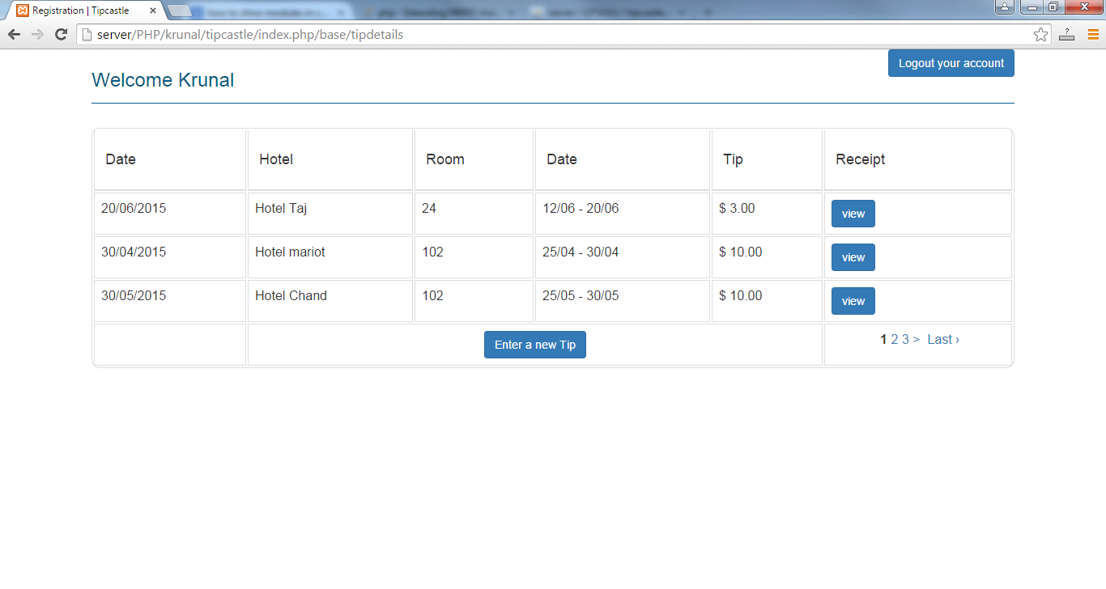

# User Tip Views:-

At each record a user can get receipt for the tip made on specific date and specific hotel. The receipts contain the details of the hotel name and it’s address, the tip amount and the name of the user and his registered address.

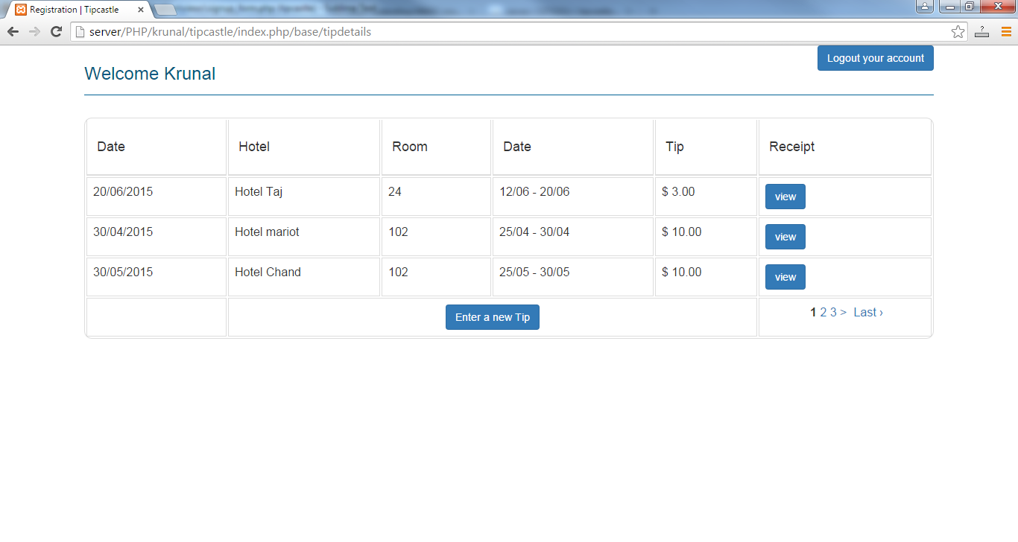

# Tip Entry (Currently working on):-

Currently we are working on the tip entry module which makes a tip to the hotel with the details like hotel name, room number, Check in and checkout date, tip amount and ratings on hotel, room and service with a note to the management, if user wants to have a note to the management.

# Search Module for Hotels:-

With the help of GOOGLE API, we would configure this module which helps the user to select the hotel by entering the city name. Google API will populate the list of hotels which are in that city or specific hotel whose name has been entered.

# Payment Gateway Module:-

Payment gateway module, this is the second process in tip entry module for giving a tip to the hotels. This module will behave as intermediate between our site and the payment collecting bank.